

**Kaedah Ciri Universal Profil Manusia**

**(Teori Perkembangan Watak Pythagoras)**

**Kompas Archetype**

Kerjaya, Perniagaan, Perhubungan dan Kejayaan Keluarga.

###### Nama :

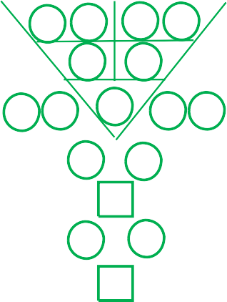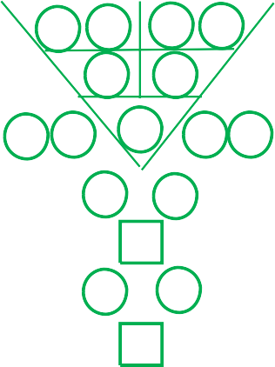

**{q} {first_name} {last_name}**

**Tarikh lahir** : **{d1} {d2}** - **{mm}** - **{y1} {y2} {y3} {y4}**

**Masa Lahir** : **{t1} {t2} : {t3} {t4}**

**Jantina** :

**Kembar atau Kembar Tiga** :

**{gender}**

**{twintrip}**

**Laporan disediakan oleh** : **{user}**

**Disediakan Pada Tarikh** : **{pd1} – {pm1} – {yy}**

|  |  |  |  |  |
| --- | --- | --- | --- | --- |
|  |  |  |  |  |

Pemproses archetype

{t3r}

{r3l}

|  |  |  |  |  |  |  |  |  |  |
| --- | --- | --- | --- | --- | --- | --- | --- | --- | --- |
| {d1} | {d2} | {mm} | | | {y1} | | {y2} | {y3} | {y4} |
|  | | | | | | | | | |
|  | {r11} | | {r12} |  | | {r13} | {r14} | |  |
|  |  | | {r21} |  | | {r22} |  | |  |
| {r31} | {r32} | |  | {r33} | |  | {r34} | | {r35} |
| {r41} | | | |  | | {r42} | | | |
|  | | | | {r51} | |  | | | |
| {r61} | | | |  | | {r62} | | | |
|  | | | | {r71} | |  | | | |

{r3r}

{t3l}

|  |  |  |  |  |  |  |  |  |  |
| --- | --- | --- | --- | --- | --- | --- | --- | --- | --- |
| {d1} | {d2} | {mm} | | | {t1} {t2} | | | {t3} | {t4} |
|  | | | | | | | | | |
|  | {t11} | | {t12} |  | | {t13} | {t14} | |  |
|  |  | | {t21} |  | | {t22} |  | |  |
| {t31} | {t32} | |  | {t33} | |  | {t34} | | {t35} |
| {t41} | | | |  | | {t42} | | | |
|  | | | | {t51} | |  | | | |
| {t61} | | | |  | | {t62} | | | |
|  | | | | {t71} | |  | | | |

Nombor Destinasi

|  |
| --- |
| **{r11} {r12} {r13} {r14}** |
| **{r33}** |
| **{r22}** |
| **{r21}** |
| **{r34} {r35}** |
| **{r31} {r32}** |
| **{hpi}** |
| **{hpb}** |
| **{ht1} {ht2} {ht3} {ht4} {ht5}** |
| **{lc1} {lc2} {lc3} {lc4}** |

Nombor Watak Sejagat   
Nombor Kelebihan Keperibadian  
Nombor Kelemahan Keperibadian Nombor Kelebihan Inborn Seumur Hidup

Nombor Cabaran Inborn Seumur Hidup  
Nombor Potensi Tersembunyi - Titik Buta  
Nombor Potensi Tersembunyi - Titik Buta Nombor Bakat Tersembunyi

Nombor Rahsia Kehidupan Anda

|  |  |  |  |  |  |  |  |  |  |  |  |  |  |  |  |  |  |
| --- | --- | --- | --- | --- | --- | --- | --- | --- | --- | --- | --- | --- | --- | --- | --- | --- | --- |
|  | **49 LanGKaH MEnGEnaL DIrI SEbEnar AnDa** | | | | | | | | | | | | | | | |  |
|  | | | | | | | | | | | | | | | |
|  | 1 | **{r33}** | 8 | **{r14} {r22}** | 15 | **{r33} {r42}** | 22 | **{r12} {r21}** | 29 | **{r33} {r34}** | 36 | **{s} {r13}** | 43 | **{r14} {r33}** |  |
| 2 | **{r11} {r12}** | 9 | **{r22}** | 16 | **{r13} {r22}** | 23 | **{r21} {r32}** | 30 | **{r14} {r21}** | 37 | **{r11} {r33}** | 44 | **{r51} {r61}** |
| 3 | **{r13} {r14}** | 10 | **{r22} {r33}** | 17 | **{r22} {r34}** | 24 | **{r21} {r31}** | 31 | **{r22} {r31}** | 38 | **{r11} {r22}** | 45 | **{r51} {r62}** |
| 4 | **{r21} {r22}** | 11 | **{r33} {r41}** | 18 | **{r22} {r35} {r13}** | 25 | **{r32} {r41}** | 32 | **{r35} {r41}** | 39 | **{r12} {r22}** | 46 | **{r61} {r71}** |
| 5 | **{r31} {r32}** | 12 | **{r11} {r21}** | 19 | **{r34} {r42}** | 26 | **{r31} {r41}** | 33 | **{r11} {r13}** | 40 | **{r12} {r33}** | 47 | **{r62} {r71}** |
| 6 | **{r34} {r35}** | 13 | **{r21}** | 20 | **{r35} {r42}** | 27 | **{r41} {r51}** | 34 | **{r11} {r14}** | 41 | **{r13} {r21}** | 48 | **{r33} {r51}** |
| 7 | **{r41} {r42}** | 14 | **{r21} {r33}** | 21 | **{r42} {r51}** | 28 | **{r32} {r33}** | 35 | **{r12} {s}** | 42 | **{r13} {r33}** | 49 | **{r51} {r71}** |
|  | | | | | | | | | | | | | | | |

**mengenaI {first_name} {last_name}**



**Sayang {first_name} {last_name}**

{r33}

Untuk memahami diri anda adalah permulaan kebijaksanaan.

###### Anda adalah, {ucInfo1}

{ucInfo2}

**Persekitaran fizikal anda, gambarkan diri anda : {rval} & {qval}**

{ucInfo3}

**Menggambarkan anda yang terbaik, anda sebenarnya : {describe}**

{ucInfo4}

###### Nombor Potensi tersembunyi anda - "Titik buta" :

###### {hiddenPotentialBlindSpot}

###### Nombor Potensi tersembunyi anda - "Gerak hati" :

{hiddenPotentialIntuition}



|  |  |  |  |
| --- | --- | --- | --- |
| **TaFsIran KOD HILanG aTau bErLEbIHan unTuK {first_name} {last_name}** | | | |
| **Nombor** | **Penerangan** | **Kuantiti** | **Status** |
| 1 | Kualiti Kepimpinan, Berdikari, Berpengaruh, Berkarisma, Inovatif, Kemahiran Interpersonal. | **{icr1} ( {icq1} )** | **{ics1}** |
| 2 | Diplomasi dalam Komunikasi dan Baik dalam Perundingan. | **{icr2} ( {icq2} )** | **{ics2}** |
| 3 | Cepat & Agresif, Berorientasikan Tugas, Pendengar yang Baik, Beroperasi. | **{icr3} ( {icq3} )** | **{ics3}** |
| 4 | Strategi, Kerja Pentadbiran, Teliti. | **{icr4} ( {icq4} )** | **{ics4}** |
| 5 | Rasa dan Hala Tuju yang Baik, Konstruktif, Membina Idea dan Konsep, Berprinsip, Berasas. | **{icr5} ( {icq5} )** | **{ics5}** |
| 6 | Berorientasikan Keluarga, Pelindung, Berkarisma, Berpengaruh, Kemahiran Interpersonal. | **{icr6} ( {icq6} )** | **{ics6}** |
| 7 | Beruntung, Giat, Dominasi, Menyelesai Masalah,  Berbilang Tugas, Penyelesaian Masalah, Bagus dalam Rundingan. | **{icr7} ( {icq7} )** | **{ics7}** |
| 8 | Yang Terselamat, Bertanggungjawab, Menilai, Berdisiplin, Gila Kerja. | **{icr8} ( {icq8} )** | **{ics8}** |
| 9 | Kreatif, Pandangan Jauh yang Baik, Pandangan Ke Hadapan, Kreatif, Berfikiran Perniagaan, Baik dalam Pembungkusan. | **{icr9} ( {icq9} )** | **{ics9}** |
|  | | | |

**Warna**

**EQ**

**DISC-O**



**NLP**

**Bentuk**

**MEnCarI pEranan mEnyOKOnG & mEnGawaL unTuK {first_name} {last_name} (MEnGInTEGrasIKan DEnGan PCDT, nLp, DIsC-O anD Eq)**

**Pilihan UCA**

**Nombor**

**Deria**

Sentuhan  
(Tangan)



Pengaruh Interpersonal

Pengurusan perhubungan

Kinaestetik (Indera peraba)

Emas, Perak, Putih

#### 1 & 6

**Pilihan Pertama** Anda Boleh Mengawal



Pendengaran (Telinga)

Penglihatan  
(Mata)

Dominan

Ketabahan yang mantap

Olfactory (Indera Penciuman)

Pengurusan diri

Operasi Sosial

Pematuhan yang teliti

Auditori (Indera pendengaran)

Hijau

Merah, Jingga, Ungu,  
Merah Jambu

Motivasi diri

Kesedaran Social

Kesedaran diri

Visual

(Indera Penglihatan)

4 & 9

**Pilihan Kedua** Menyokong Anda

**Pilihan Ketiga** Elemen Anda Sendiri

**Pilihan Keempat** Anda Menyokong

**Pilihan Kelima** Mengawal Anda



3 & 8

Kuning, Coklat, Kuning air



Melalui bau (Hidung)

#### 5

Hitam, Biru gelap

Gusti

(Indra perasa)



Percakapan (Mulut)

2 & 7

**CaDanGan reka bentuk untuk**

**nombor rahsia kehidupan anda**





# {lc1} {lc2} {lc3} {lc4} {lc1} {lc2} {lc3} {lc4}

**{lc1} {lc2} {lc3} {lc4}**



|  |  |
| --- | --- |
| **Pilihan kerjaya yang menyokong & mengawal untuk {first_name} {last_name}** | |
| 1 & 6  **Pilihan Pertama** Anda Boleh Mengawal | {pc1} |
| 4 & 9  **Pilihan Kedua** Menyokong Anda | {pc2} |
| 3 & 8  **Pilihan Ketiga** Elemen Anda Sendiri | {pc3} |
| 5  **Pilihan Keempat** Anda Menyokong | {pc4} |
| 2 & 7  **Pilihan Kelima** Mengawal Anda | {pc5} |
|  | |

Potensi Penyakit Turun Temurun

Potensi Isu Serviks/Prostat

Potential Heart Bypass : {pothb}

Potensi Pintasan Jantung

Potensi Serangan Jantung

Potensi Barah

Potential Heart Attack : {potha}

|  |  |  |  |  |
| --- | --- | --- | --- | --- |
| **PEmErIKsaan KEsIHaTan pErIbaDI unTuK {first_name} {last_name}** | | | | |
| **Bahagian Badan Utama** | | **Kuantiti** | **Status** | |
| **Paru-Paru** | Paru-Paru/Masalah Usus Besar, Asma, Masalah Alahan Kulit, Rhinitis Alergi. | **{hpr1} ( {hpq1} )** | **{hps1}** | |
| **Buah Pinggang** | Ginjal/Masalah Pundi Kencing, Takut/Fobia, Sakit Pinggang, Sciatica, Kerap Buang Air Kecil, Bayangan Gelap/Beg di Bawah Mata, Gangguan Sistem Saraf Pusat, Tidak serasi kepada Sejuk, Mati Pucuk/Dorongan Seks yang Rendah. | **{hpr2} ( {hpq2} )** | **{hps2}** | |
| **Jantung** | Jantung/Masalah Usus Kecil, Penyakit Jantung, Insomnia, Kegelisahan, Pelupa, Gangguan Pertuturan, Kemurungan, Sakit di Kawasan Dada, Hipersensitif. | **{hpr3} ( {hpq3} )** | **{hps3}** | |
| **Hati** | Hati/Masalah Pundi Hempedu, Kemarahan/Ketidaan Sepenuhnya, Tidak Sabar/Mudah Kecewa, Masalah Mata, Masalah Keseimbangan / Koordinasi, Kekejangan Otot, Kurang Fleksibiliti/Kekakuan, Rasa Pahit di Mulut, Haid Tidak Teratur, Masalah Tendor. | **{hpr4} ( {hpq4} )** | **{hps4}** | |
| **Perut** | Perut/Pankreas/Masalah Limpa, Masalah Sistem Imun, Masalah Pencernaan, Sendawa, Kekurangan Penyerapan, Usus Longgar, Anemia, Buasir, Berat Badan, Ketidakupayaan Menerima Nutrien, Masalah Limfa. | **{hpr5} ( {hpq5} )** | **{hps5}** | |
|  | | | | {pothd} |
| {potp} |
|  |

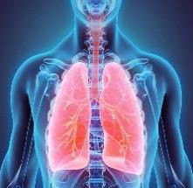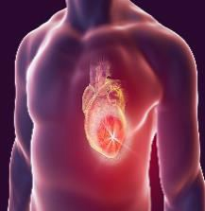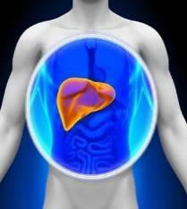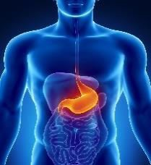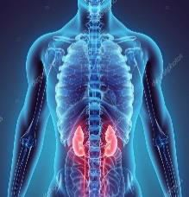

Potential Cancer : {potc}

#### Potential Hereditary Diseases :

Potential Cervical/Prostate Issue :

**9 TaHun TInJauan DunIa unTuK {first_name} {last_name}**

**Tahun**

**Tahun**

**Tahun**

{w33l}

{w3l}

{w3r}

{w23l}

{w23r}

{w33r}

|  |  |  |  |  |  |  |  |  |  |
| --- | --- | --- | --- | --- | --- | --- | --- | --- | --- |
|  | |  | | | {wy11} | | {wy12} | {wy13} | {wy14} |
| {d1} | {d2} | {mm} | | |  | | |  | |
|  | {w11} | | {w12} |  | | {w13} | {w14} | |  |
|  |  | | {w21} |  | | {w22} |  | |  |
| {w31} | {w32} | |  | {w33**}** | |  | {w34} | | {w35} |
| {w41} | | | |  | | {w42} | | | |
|  | | | | {w51} | |  | | | |
| {w61} | | | |  | | {w62} | | | |
|  | | | | {w71} | |  | | | |
|  | | | | | | | | | |

|  |  |  |  |  |  |  |  |  |  |
| --- | --- | --- | --- | --- | --- | --- | --- | --- | --- |
|  | |  | | | {wy21} | | {wy22} | {wy23} | {wy24} |
| {d1} | {d2} | {mm} | | |  | | |  | |
|  | {w211} | | {w212} |  | | {w213} | {w214} | |  |
|  |  | | {w221} |  | | {w222} |  | |  |
| {w231} | {w232} | |  | {w233} | |  | {w234} | | {w235} |
| {w241} | | | |  | | {w242} | | | |
|  | | | | {w251} | |  | | | |
| {w261} | | | |  | | {w262} | | | |
|  | | | | {w271} | |  | | | |
|  | | | | | | | | | |

|  |  |  |  |  |  |  |  |  |  |
| --- | --- | --- | --- | --- | --- | --- | --- | --- | --- |
|  | |  | | | {wy31} {wy32} | | | {wy33} | {wy34} |
| {d1} | {d2} | {mm} | | |  | | |  | |
|  | {w311} | | {w312} |  | | {w313} | {w314} | |  |
|  |  | | {w321} |  | | {w322} |  | |  |
| {w331} | {w332} | |  | {w333} | |  | {w334} | | {w335} |
|  |  | | {w341} |  | | {w342} |  | |  |
|  |  | |  | {w351} | |  |  | |  |
|  |  | | {w361} |  | | {w362} |  | |  |
|  |  | |  | {w371} | |  |  | |  |
|  | | | | | | | | | |

**Tahun**

**Tahun**

**Tahun**

{w63l}

{w43l}

{w43r}

{w53l}

{w53r}

{w63r}

|  |  |  |  |  |  |  |  |  |  |
| --- | --- | --- | --- | --- | --- | --- | --- | --- | --- |
|  | |  | | | {wy41} | | {wy42} | {wy43} | {wy44} |
| {d1} | {d2} | {mm} | | |  | | |  | |
|  | {w411} | | {w412} |  | | {w413} | {w414} | |  |
|  |  | | {w421} |  | | {w422} |  | |  |
| {w431} | {w432} | |  | {w433} | |  | {w434} | | {w435} |
| {w441} | | | |  | | {w442} | | | |
|  | | | | {w451} | |  | | | |
| {w461} | | | |  | | {w462} | | | |
|  | | | | {w471} | |  | | | |
|  | | | | | | | | | |

|  |  |  |  |  |  |  |  |  |  |
| --- | --- | --- | --- | --- | --- | --- | --- | --- | --- |
|  | |  | | | {wy51} | | {wy52} | {wy53} | {wy54} |
| {d1} | {d2} | {mm} | | |  | | |  | |
|  | {w511} | | {w512} |  | | {w513} | {w514} | |  |
|  |  | | {w521} |  | | {w522} |  | |  |
| {w531} | {w532} | |  | {w533} | |  | {w534} | | {w535} |
| {w541} | | | |  | | {w542} | | | |
|  | | | | {w551} | |  | | | |
| {w561} | | | |  | | {w562} | | | |
|  | | | | {w571} | |  | | | |
|  | | | | | | | | | |

|  |  |  |  |  |  |  |  |  |  |
| --- | --- | --- | --- | --- | --- | --- | --- | --- | --- |
|  | |  | | | {wy61} {wy62} | | | {wy63} | {wy64} |
| {d1} | {d2} | {mm} | | |  | | |  | |
|  | {w611} | | {w612} |  | | {w613} | {w614} | |  |
|  |  | | {w621} |  | | {w622} |  | |  |
| {w631} | {w632} | |  | {w633} | |  | {w634} | | {w635} |
|  |  | | {w641} |  | | {w642} |  | |  |
|  |  | |  | {w651} | |  |  | |  |
|  |  | | {w661} |  | | {w662} |  | |  |
|  |  | |  | {w671} | |  |  | |  |
|  | | | | | | | | | |

**Tahun**

**Tahun**

**Tahun**

**{wy91} {wy92} {wy93} {wy94}**

**{wy81} {wy82} {wy83} {wy84}**

**{wy71} {wy72} {wy73} {wy74}**

**{wy61} {wy62} {wy63} {wy64}**

**{wy51} {wy52} {wy53} {wy54}**

**{wy41} {wy42} {wy43} {wy44}**

**{wy31} {wy32} {wy33} {wy34}**

**{wy21} {wy22} {wy23} {wy24}**

**{wy11} {wy12} {wy13} {wy14}**

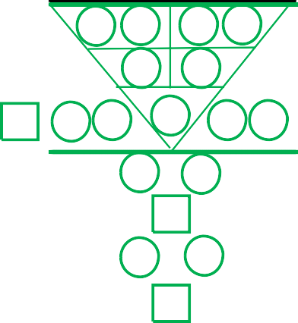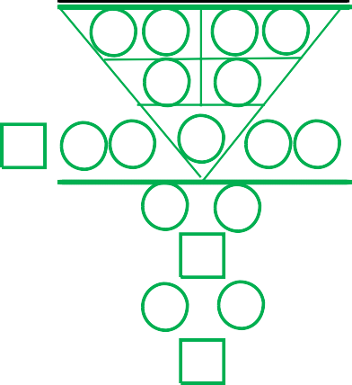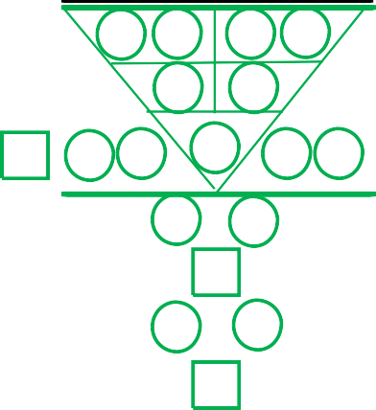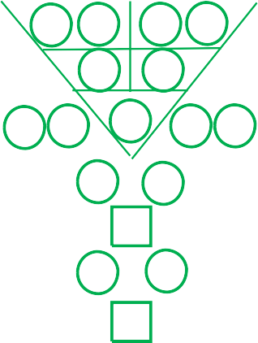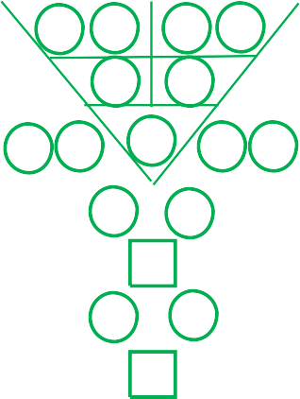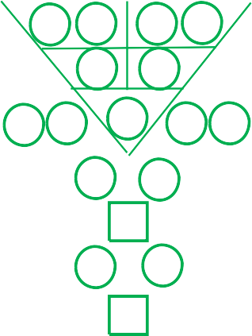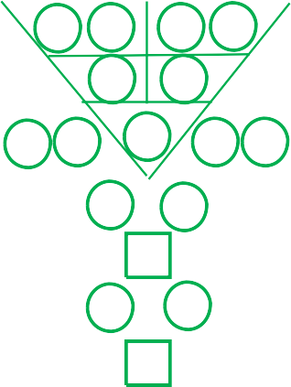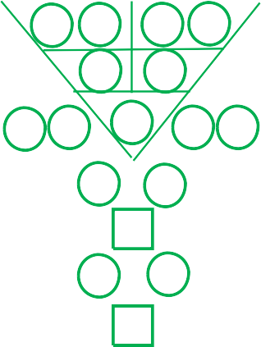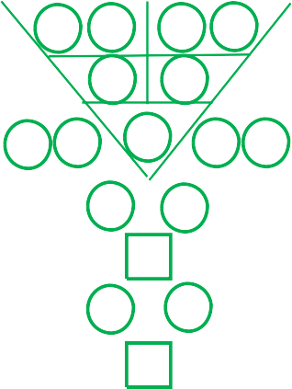

{w93l}

{w73l}

{w73r}

{w83l}

{w83r}

{w93r}

|  |  |  |  |  |  |  |  |  |  |
| --- | --- | --- | --- | --- | --- | --- | --- | --- | --- |
|  | |  | | | {wy71} | | {wy72} | {wy73} | {wy74} |
| {d1} | {d2} | {mm} | | |  | | |  | |
|  | {w711} | | {w712} |  | | {w713} | {w714} | |  |
|  |  | | {w721} |  | | {w722} |  | |  |
| {w731} | {w732} | |  | {w733} | |  | {w734} | | {w735} |
| {w741} | | | |  | | {w742} | | | |
|  | | | | {w751} | |  | | | |
| {w761} | | | |  | | {w762} | | | |
|  | | | | {w771} | |  | | | |
|  | | | | | | | | | |

|  |  |  |  |  |  |  |  |  |  |
| --- | --- | --- | --- | --- | --- | --- | --- | --- | --- |
|  | |  | | | {wy81} | | {wy82} | {wy83} | {wy84} |
| {d1} | {d2} | {mm} | | |  | | |  | |
|  | {w811} | | {w812} |  | | {w813} | {w814} | |  |
|  |  | | {w821} |  | | {w822} |  | |  |
| {w831} | {w832} | |  | {w833} | |  | {w834} | | {w835} |
| {w841} | | | |  | | {w842} | | | |
|  | | | | {w851} | |  | | | |
| {w861} | | | |  | | {w862} | | | |
|  | | | | {w871} | |  | | | |
|  | | | | | | | | | |

|  |  |  |  |  |  |  |  |  |  |
| --- | --- | --- | --- | --- | --- | --- | --- | --- | --- |
|  | |  | | | {wy91} {wy92} | | | {wy93} | {wy94} |
| {d1} | {d2} | {mm} | | |  | | |  | |
|  | {w911} | | {w912} |  | | {w913} | {w914} | |  |
|  |  | | {w921} |  | | {w922} |  | |  |
| {w931} | {w932} | |  | {w933} | |  | {w934} | | {w935} |
|  |  | | {w941} |  | | {w942} |  | |  |
|  |  | |  | {w951} | |  |  | |  |
|  |  | | {w961} |  | | {w962} |  | |  |
|  |  | |  | {w971} | |  |  | |  |
|  | | | | | | | | | |

**PanDanGan DunIa buLanan 2022 unTuK {first_name} {last_name}**

**Tahun Tahun Tahun**

**{my11} {my12} {my13} {my14}**

**{my11} {my12} {my13} {my14}**

**{my11} {my12} {my13} {my14}**

**{my11} {my12} {my13} {my14}**

**{my11} {my12} {my13} {my14}**

**{my11} {my12} {my13} {my14}**

**{my11} {my12} {my13} {my14}**

**{my11} {my12} {my13} {my14}**

**{my11} {my12} {my13} {my14}**

|  |  |  |  |  |  |  |  |  |  |
| --- | --- | --- | --- | --- | --- | --- | --- | --- | --- |
|  | | 0 1 | | | {my11} | | {my12} | {my13} | {my14} |
| {d1} | {d2} | {mm} | | |  | | |  | |
|  | {m11} | | {m12} |  | | {m13} | {m14} | |  |
|  |  | | {m21} |  | | {m22} |  | |  |
| {m31} | {m32} | |  | {m33} | |  | {m34} | | {m35} |
| {m41} | | | |  | | {m42} | | | |
|  | | | | {m51} | |  | | | |
| {m61} | | | |  | | {m62} | | | |
|  | | | | {m71} | |  | | | |
|  | | | | | | | | | |

|  |  |  |  |  |  |  |  |  |  |
| --- | --- | --- | --- | --- | --- | --- | --- | --- | --- |
|  | | 0 2 | | | {my11} | | {my12} | {my13} | {my14} |
| {d1} | {d2} | {mm} | | |  | | |  | |
|  | {m211} | | {m212} |  | | {m213} | {m214} | |  |
|  |  | | {m221} |  | | {m222} |  | |  |
| {m231} | {m232} | |  | {m233} | |  | {m234} | | {m235} |
| {m241} | | | |  | | {m242} | | | |
|  | | | | {m251} | |  | | | |
| {m261} | | | |  | | {m262} | | | |
|  | | | | {m271} | |  | | | |
|  | | | | | | | | | |

|  |  |  |  |  |  |  |  |  |  |
| --- | --- | --- | --- | --- | --- | --- | --- | --- | --- |
|  | | 0 3 | | | {my11} {my12} | | | {my13} | {my14} |
| {d1} | {d2} | {mm} | | |  | | |  | |
|  | {m311} | | {m312} |  | | {m313} | {m314} | |  |
|  |  | | {m321} |  | | {m322} |  | |  |
| {m331} | {m332} | |  | {m333} | |  | {m334} | | {m335} |
|  |  | | {m341} |  | | {m342} |  | |  |
|  |  | |  | {m351} | |  |  | |  |
|  |  | | {m361} |  | | {m362} |  | |  |
|  |  | |  | {m371} | |  |  | |  |
|  | | | | | | | | | |

{m33l}

{m3l}

{m3r}

{m23l}

{m23r}

{m33r}

**Tahun**

|  |  |  |  |  |  |  |  |  |  |
| --- | --- | --- | --- | --- | --- | --- | --- | --- | --- |
|  | | 0 4 | | | {my11} | | {my12} | {my13} | {my14} |
| {d1} | {d2} | {mm} | | |  | | |  | |
|  | {m411} | | {m412} |  | | {m413} | {m414} | |  |
|  |  | | {m421} |  | | {m422} |  | |  |
| {m431} | {m432} | |  | {m433} | |  | {m434} | | {m435} |
| {m441} | | | |  | | {m442} | | | |
|  | | | | {m451} | |  | | | |
| {m461} | | | |  | | {m462} | | | |
|  | | | | {m471} | |  | | | |
|  | | | | | | | | | |

**Tahun**

**Tahun**

|  |  |  |  |  |  |  |  |  |  |
| --- | --- | --- | --- | --- | --- | --- | --- | --- | --- |
|  | | 0 6 | | | {my11} {my12} | | | {my13} | {my14} |
| {d1} | {d2} | {mm} | | |  | | |  | |
|  | {m611} | | {m612} |  | | {m613} | {m614} | |  |
|  |  | | {m621} |  | | {m622} |  | |  |
| {m631} | {m632} | |  | {m633} | |  | {m634} | | {m635} |
|  |  | | {m641} |  | | {m642} |  | |  |
|  |  | |  | {m651} | |  |  | |  |
|  |  | | {m661} |  | | {m662} |  | |  |
|  |  | |  | {m671} | |  |  | |  |
|  | | | | | | | | | |

{m63l}

{m43l}

{m43r}

{m53l}

{m53r}

{m63r}

**Tahun**

|  |  |  |  |  |  |  |  |  |  |
| --- | --- | --- | --- | --- | --- | --- | --- | --- | --- |
|  | | 0 5 | | | {my11} | | {my12} | {my13} | {my14} |
| {d1} | {d2} | {mm} | | |  | | |  | |
|  | {m511} | | {m512} |  | | {m513} | {m514} | |  |
|  |  | | {m521} |  | | {m522} |  | |  |
| {m531} | {m532} | |  | {m533} | |  | {m534} | | {m535} |
| {m541} | | | |  | | {m542} | | | |
|  | | | | {m551} | |  | | | |
| {m561} | | | |  | | {m562} | | | |
|  | | | | {m571} | |  | | | |
|  | | | | | | | | | |

|  |  |  |  |  |  |  |  |  |  |
| --- | --- | --- | --- | --- | --- | --- | --- | --- | --- |
|  | | 0 7 | | | {my11} | | {my12} | {my13} | {my14} |
| {d1} | {d2} | {mm} | | |  | | |  | |
|  | {m711} | | {m712} |  | | {m713} | {m714} | |  |
|  |  | | {m721} |  | | {m722} |  | |  |
| {m731} | {m732} | |  | {m733} | |  | {m734} | | {m735} |
| {m741} | | | |  | | {m742} | | | |
|  | | | | {m751} | |  | | | |
| {m761} | | | |  | | {m762} | | | |
|  | | | | {m771} | |  | | | |
|  | | | | | | | | | |

|  |  |  |  |  |  |  |  |  |  |
| --- | --- | --- | --- | --- | --- | --- | --- | --- | --- |
|  | | 0 8 | | | {my11} | | {my12} | {my13} | {my14} |
| {d1} | {d2} | {mm} | | |  | | |  | |
|  | {m811} | | {m812} |  | | {m813} | {m814} | |  |
|  |  | | {m821} |  | | {m822} |  | |  |
| {m831} | {m832} | |  | {m833} | |  | {m834} | | {m835} |
| {m841} | | | |  | | {m842} | | | |
|  | | | | {m851} | |  | | | |
| {m861} | | | |  | | {m862} | | | |
|  | | | | {m871} | |  | | | |
|  | | | | | | | | | |

**Tahun**

**Tahun**

|  |  |  |  |  |  |  |  |  |  |
| --- | --- | --- | --- | --- | --- | --- | --- | --- | --- |
|  | | 0 9 | | | {my11} {my12} | | | {my13} | {my14} |
| {d1} | {d2} | {mm} | | |  | | |  | |
|  | {m911} | | {m912} |  | | {m913} | {m914} | |  |
|  |  | | {m921} |  | | {m922} |  | |  |
| {m931} | {m932} | |  | {m933} | |  | {m934} | | {m935} |
|  |  | | {m941} |  | | {m942} |  | |  |
|  |  | |  | {m951} | |  |  | |  |
|  |  | | {m961} |  | | {m962} |  | |  |
|  |  | |  | {m971} | |  |  | |  |
|  | | | | | | | | | |

**Apr**

**Mei**

**Jun**

**Sep**

**Ogos**

**Julai**

**Mac & Dis**

**Feb & Nov**

**Jan & Okt**

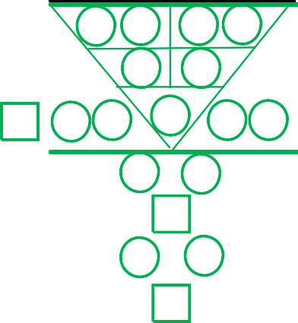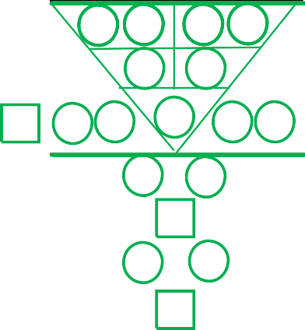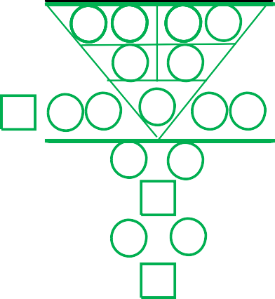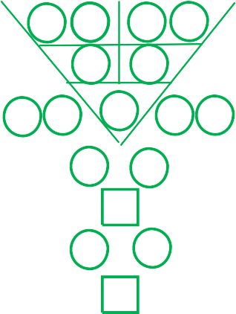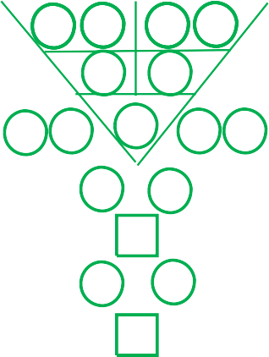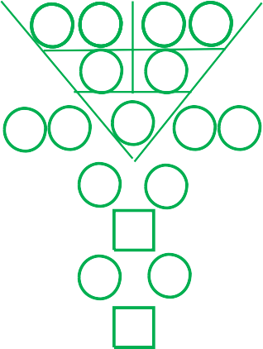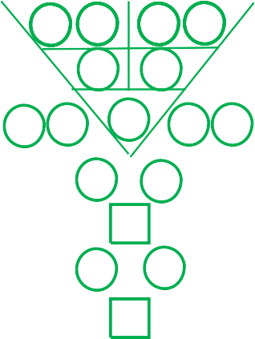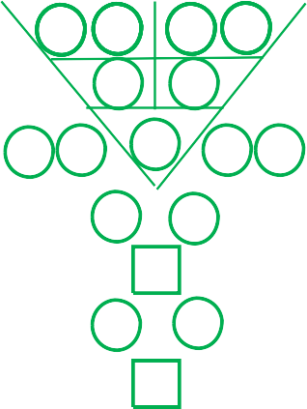

{m93l}

{m73l}

{m73r}

{m83l}

{m83r}

{m93r}

**9 TaHun panDanGan pErIbaDI unTuK {first_name} {last_name}**

**Tahun Tahun Tahun**

|  |  |  |  |  |  |  |  |  |  |
| --- | --- | --- | --- | --- | --- | --- | --- | --- | --- |
|  | |  | | | {py11} | | {py12} | {py13} | {py14} |
| {d1} | {d2} | {mm} | | | {y1} {y2} | | | {y3} {y4} | |
|  | {p111} | | {p112} |  | | {p113} | {p114} | |  |
|  |  | | {p121} |  | | {p122} |  | |  |
| {p131} | {p132} | |  | {p133} | |  | {p134} | | {p135} |
| {p141} | | | |  | | {p142} | | | |
|  | | | | {p151} | |  | | | |
| {p161} | | | |  | | {p162} | | | |
|  | | | | {p171} | |  | | | |
|  | | | | | | | | | |

|  |  |  |  |  |  |  |  |  |  |
| --- | --- | --- | --- | --- | --- | --- | --- | --- | --- |
|  | |  | | | {py21} | | {py22} | {py23} | {py24} |
| {d1} | {d2} | {mm} | | | {y1} {y2} | | | {y3} {y4} | |
|  | {p211} | | {p212} |  | | {p213} | {p214} | |  |
|  |  | | {p221} |  | | {p222} |  | |  |
| {p231} | {p232} | |  | {p233} | |  | {p234} | | {p235} |
| {p241} | | | |  | | {p242} | | | |
|  | | | | {p251} | |  | | | |
| {p261} | | | |  | | {p262} | | | |
|  | | | | {p271} | |  | | | |
|  | | | | | | | | | |

|  |  |  |  |  |  |  |  |  |  |
| --- | --- | --- | --- | --- | --- | --- | --- | --- | --- |
|  | |  | | | {py31} {py32} | | | {py33} | {py34} |
| {d1} | {d2} | {mm} | | | {y1} {y2} | | | {y3} {y4} | |
|  | {p311} | | {p312} |  | | {p313} | {p314} | |  |
|  |  | | {p321} |  | | {p322} |  | |  |
| {p331} | {p332} | |  | {p333} | |  | {p334} | | {p335} |
|  |  | | {p341} |  | | {p342} |  | |  |
|  |  | |  | {p351} | |  |  | |  |
|  |  | | {p361} |  | | {p362} |  | |  |
|  |  | |  | {p371} | |  |  | |  |
|  | | | | | | | | | |

{p33l}

{p13l}

{p13r}

{p23l}

{p23r}

{p33r}

**Tahun**

|  |  |  |  |  |  |  |  |  |  |
| --- | --- | --- | --- | --- | --- | --- | --- | --- | --- |
|  | |  | | | {py41} | | {py42} | {py43} | {py44} |
| {d1} | {d2} | {mm} | | | {y1} {y2} | | | {y3} {y4} | |
|  | {p411} | | {p412} |  | | {p413} | {p414} | |  |
|  |  | | {p421} |  | | {p422} |  | |  |
| {p431} | {p432} | |  | {p433} | |  | {p434} | | {p435} |
| {p441} | | | |  | | {p442} | | | |
|  | | | | {p451} | |  | | | |
| {p461} | | | |  | | {p462} | | | |
|  | | | | {p471} | |  | | | |
|  | | | | | | | | | |

**Tahun**

|  |  |  |  |  |  |  |  |  |  |
| --- | --- | --- | --- | --- | --- | --- | --- | --- | --- |
|  | |  | | | {py51} | | {py52} | {py53} | {py54} |
| {d1} | {d2} | {mm} | | | {y1} {y2} | | | {y3} {y4} | |
|  | {p511} | | {p512} |  | | {p513} | {p514} | |  |
|  |  | | {p521} |  | | {p522} |  | |  |
| {p531} | {p532} | |  | {p533} | |  | {p534} | | {p535} |
| {p541} | | | |  | | {p542} | | | |
|  | | | | {p551} | |  | | | |
| {p561} | | | |  | | {p562} | | | |
|  | | | | {p571} | |  | | | |
|  | | | | | | | | | |

**Tahun**

|  |  |  |  |  |  |  |  |  |  |
| --- | --- | --- | --- | --- | --- | --- | --- | --- | --- |
|  | |  | | | {py61} {py62} | | | {py63} | {py64} |
| {d1} | {d2} | {mm} | | | {y1} {y2} | | | {y3} {y4} | |
|  | {p611} | | {p612} |  | | {p613} | {p614} | |  |
|  |  | | {p621} |  | | {p622} |  | |  |
| {p631} | {p632} | |  | {p633} | |  | {p634} | | {p635} |
|  |  | | {p641} |  | | {p642} |  | |  |
|  |  | |  | {p651} | |  |  | |  |
|  |  | | {p661} |  | | {p662} |  | |  |
|  |  | |  | {p671} | |  |  | |  |
|  | | | | | | | | | |

{p63l}

{p43l}

{p43r}

{p53l}

{p53r}

{p63r}

**Tahun**

|  |  |  |  |  |  |  |  |  |  |
| --- | --- | --- | --- | --- | --- | --- | --- | --- | --- |
|  | |  | | | {py71} | | {py72} | {py73} | {py74} |
| {d1} | {d2} | {mm} | | | {y1} {y2} | | | {y3} {y4} | |
|  | {p711} | | {p712} |  | | {p713} | {p714} | |  |
|  |  | | {p721} |  | | {p722} |  | |  |
| {p731} | {p732} | |  | {p733} | |  | {p734} | | {p735} |
| {p741} | | | |  | | {p742} | | | |
|  | | | | {p751} | |  | | | |
| {p761} | | | |  | | {p762} | | | |
|  | | | | {p771} | |  | | | |
|  | | | | | | | | | |

**Tahun**

|  |  |  |  |  |  |  |  |  |  |
| --- | --- | --- | --- | --- | --- | --- | --- | --- | --- |
|  | |  | | | {py81} | | {py82} | {py83} | {py84} |
| {d1} | {d2} | {mm} | | | {y1} {y2} | | | {y3} {y4} | |
|  | {p811} | | {p812} |  | | {p813} | {p814} | |  |
|  |  | | {p821} |  | | {p822} |  | |  |
| {p831} | {p832} | |  | {p833} | |  | {p834} | | {p835} |
| {p841} | | | |  | | {p842} | | | |
|  | | | | {p851} | |  | | | |
| {p861} | | | |  | | {p862} | | | |
|  | | | | {p871} | |  | | | |
|  | | | | | | | | | |

**Tahun**

|  |  |  |  |  |  |  |  |  |  |
| --- | --- | --- | --- | --- | --- | --- | --- | --- | --- |
|  | |  | | | {py91} {py92} | | | {py93} | {py94} |
| {d1} | {d2} | {mm} | | | {y1} {y2} | | | {y3} {y4} | |
|  | {p911} | | {p912} |  | | {p913} | {p914} | |  |
|  |  | | {p921} |  | | {p922} |  | |  |
| {p931} | {p932} | |  | {p933} | |  | {p934} | | {p935} |
|  |  | | {p941} |  | | {p942} |  | |  |
|  |  | |  | {p951} | |  |  | |  |
|  |  | | {p961} |  | | {p962} |  | |  |
|  |  | |  | {p971} | |  |  | |  |
|  | | | | | | | | | |

**{py91} {py92} {py93} {py94}**

**{py81} {py82} {py83} {py84}**

**{py71} {py72} {py73} {py74}**

**{py61} {py62} {py63} {py64}**

**{py51} {py52} {py53} {py54}**

**{py41} {py42} {py43} {py44}**

**{py31} {py32} {py33} {py34}**

**{py21} {py22} {py23} {py24}**

**{py11} {py12} {py13} {py14}**



{p93l}

{p73l}

{p73r}

{p83l}

{p83r}

{p93r}

**KEJELASAN PERJALANAN HIDUP**

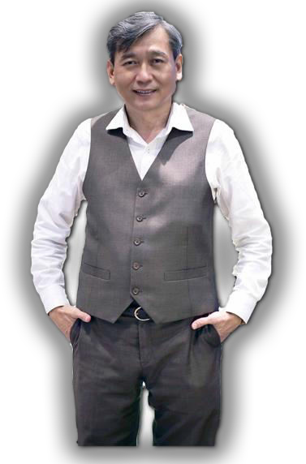

***Kejernihan fikiran dan hati adalah kunci membantu memperkasakan anda untuk membuat keputusan yang tepat, meramal dan mencegah cabaran dalam semua perjalanan hidup masa depan anda.***

***~ Dr Bernard Yeo, Hon PhD***

***Dr Bernard Yeo adalah penyelidik dan pengasas Universal Characteristic Method of Human Profiling (UCMHP) dan 1st Character Coach di seluruh dunia. Beliau telah melakukan kajian intensif selama lebih dari 12 tahun untuk mengenali tingkah laku manusia, keperibadian dan sifat watak mereka.***

***Beliau secara peribadi telah menganalisis lebih daripada 15,000 nombor kelahiran individu yang berasal dari pelbagai budaya, jantina dan latar belakang.***

***Pada tahun 2012, Dr Bernard Yeo menerima Anugerah Profesional Perniagaan Luar Biasa Asia Pasifik untuk karya perintis dan sumbangannya dalam bidang profil watak sains gunaan. Beliau kemudiannya dianugerahkan pada tahun 2013 Doktor Kehormatan Falsafah dalam Pembangunan Modal Insan dan Profil Manusia sebagai pengiktirafan atas kajiaanya yang cemerlang.***

***Dr Bernard Yeo meneruskan penggalian lebih mendalam mengenai wawasan misteri mengenai kejelasan jiwa manusia dan berkongsi penemuannya dengan seluruh dunia.***

##### UCMHP Academy Pte Ltd

**3 Irving Road, #01-09, Tai Seng Centre Singapore 369522**

**Tel: (65) 6748 6279 Email:** [**cs@ucmhpacademy.com**](mailto:cs@ucmhpacademy.com)

[**www.ucmhpacademy.com**](http://www.ucmhpacademy.com/) **Facebook:** [**www.facebook.com/UCMHP**](http://www.facebook.com/UCMHP)

**®**

Hak Cipta © 2012 UCMHP Academy Pte Ltd, Hak Cipta Terpelihara